Desktop Framework
https://www.youtube.com/watch?v=W-36NmDoSdg – Wrong Java
https://www.youtube.com/watch?v=nqPJcAf_xsE&list=PL7BYd102yEfWoYBUkbQttxYd6gsAgFZBg

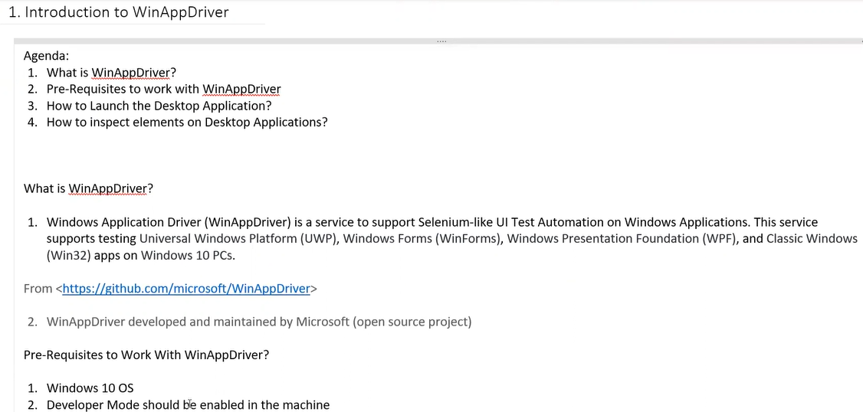
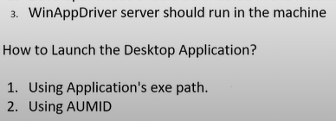
https://github.com/microsoft/WinAppDriver
Need to do developer mode

